Access Networks

 Part of the communication network that directly connects the customer with the service provider (e.g. Internet).
 Can be built using
1. Wireless technology
2. Metallic symmetric or asymmetrical lines
3. Optical fiber

XDSL

 called as DSL (Digital Subscriber Line) family
 include several variations, the lower case x in front of DSL include:
- Asymmetric Digital Subscriber Line (ADSL)
- ISDN (like) Digital Subscriber Line (IDSL)
- Consumer Digital Subscriber Line (CDSL)
- Single High Speed DSL (SHDSL)
- Rate-adaptive Subscriber Digital Line (RADSL)
- Very High-bit Rate Digital Subscriber Line (VDSL)
- Symmetric Digital Subscriber Line (SDSL)

ADSL sytems

 Asymmetric Digital Subscriber Line
 converge (yakinsamak) the existing twisted (bukulmus) pair telephone lines into the high-speed communications access
 modem technology used to transmit speeds of between 1,5 Mbps and 6 Mbps
 asymmetric = data flow is greater in one direction than the other
 communication is full duplex using most the FDD (Frequency Division Duplex)
 two separate bands – upstream and downstream
 upstream 25,875 kHz to 138 kHz
 downstream 138 kHz – 1104 kHz

• DSL and POTS (Plain (duz, sade) Old Telephone Service) band is splitted (bolunmus) by so called (sozde) splitter (bolucu) – low pass filter (alçak geçiş filtresi)

• main component is DSLAM (DSL Access Multiplexer)
- located in the telephony exchanges of the service providers
- intermixes (birbirine karismak, karistirmak) voice traffic and DSL traffic on the customer’s DSL line
- collects the data from its many modem ports and aggregates (haline getirmek) their voice and data traffic into one complex composite (karma, karisik) signal via (yolu ile) multiplexing
- acts (davranmak) like a massive (buyuk) network switch since its functionality is only on L2
- each DSLAM has multiple (coklu) aggregation (toplama) cards, and each such card can have multiple ports (baglanti noktasi) to which the customers lines are connected

ADSL standards
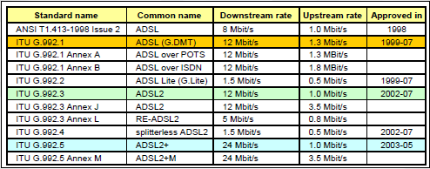

 ADSL (G.DMT)
- using discrete multitone (cok tonlu) modulation
- separates the ADSL signal into 255 carriers (binds/tones) centered on multiples (katlar) of 4.3125 kHz
- DMT has 224 downstream frequency bins (kutular) and up to 31 upstream bins
- up to 15 bits per symbol (sembol basina) can be encoded on each bin on a good quality line
- the number of bits encoded on each bin depending on the attenuation (zayiflama) and signal to noise ratio for that bin (o kutunun sinyal gurultu orani), tones are independent of one another
- QAM or phase-shift keying (PSK) is used to encode the bits within each bin
- when the modem is initialized (baslatilmak), the number of bits assigned (atanmak) to a tone is set (ayarlamak) to compensate (karsilamak, teleafi etmek) the differences in transmission characteristics of line
- Bits rates can be adjusted (ayarlanmak) in small increments (artis) of a few tens of kilobits per second

Preview (onizleme) the arrangement (duzen) of individual bits on each sub-carrier

ADSL2

 ITU-T G.992.3 and G.992.4
 adds new features and functionality targeted (hedefleyen) at improving performance and interoperability (birlikte calisilabilirlik)
- dynamic data rate adaptation
- flexible structure of frame
- reduces (dusurmek, azaltmak, kisaltmak) the initialization time to less than 3 seconds
 improve data rates
- 12 Mbit/s downlink
- 3,5 Mbit/s uplink

ADSL2+

 extends (genisletmek, uzatmak) the capability of basic ADSL by (ile) increased frequency band to 2,208 MHz
• DMT (Discrete Multitone (cok tonlu) Modulation) has 511 downstream frequency bins and up to 36 upstream bins
• data rates can be 24 Mbit/s for downstrem – short local loop
• local loop > 3 km – problem with attenuation (zayiflama) and crosstalk (karisma)

VDSL

 Very-High-Data-Rate Digital Subscriber Line
 same philosophy (felsefe) as ADSL
 up to 30 MHz, max 1.6 km
 max 52 Mbit/s for downstream, 6.4 Mbit/s upstream
 transmission range is very short according to ADSL (the biggest difference)

VDSL2

 Very-High-Data-Rate Digital Subscriber Line version 2
 same philosophy (felsefe) as ADSL
 up to 30 MHz with wider bandwith of subchannels 8,625 kHz
 max 52 Mbit/s for downstream, 6.4 Mbit/s upstream

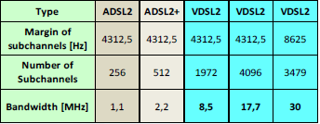

G.FAST

 under G.9701, approved (onayli) 12/2014
 up to 106 Mhz
 for short loops (up to 250m)
 < 100m “ 1Gbps, 200m ” 500Mbps, 300m “ 300Mbps
 problem with crosstalk between multiple wire pairs
 self-FEXT (far-end (dip) crosstalk) cancellation is done by vectoring

Installation

DOCSIS

 Data Over Cable Service Interface Specification (Kablo Servisi Üzerinden Veri Arayüz Spesifikasyonu)
 defines interface requirements for cable modems involved (ile ilgili) in high-speed data distribution (dagitim) over CATV systems
 developed by CableLabs
 frequency allocation band plans differ between U.S. and European CATV -> EuroDOCSIS
 3 versions of standart (1.0, 2.0, 3.0)
 version 3.1 ratified (onaylanmak) in 2014

 CPE (Customer Premises (mulk) Equipment) – most often the PC
 CM (Cable Modem) – located at the customer premises
 CMTS (Cable Modem Termination System) – located at the CATV headend (Kablo başı)
 HFC (Hybrid Fibre-Coax) is a network which is based on a combination of optical fibre and coaxial cable

DOCSIS – Protocol Stack

 defined the characteristics for first and second layer
 Physical Layer
- 5-85 MHz for upstream
- 254-1218 MHz for downstream
- OFDM/OFDMA use up to 8k subcarriers
- up to 4096QAM, in future up to 16384QAM
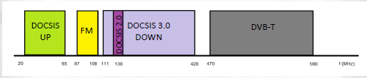
Example of arrangement (duzenleme) of spectrum

 MAC layer
- DOCSIS frame is defined
- QoS and capacity assignment (atama)

IPTV

 Internet Protocol Television
 service for the delivery of broadcast TV
 IPTV system may also include Internet services such as Web access and VOIP where it may be called Triple Play and is typically supplied by a broadband (genis bant) operator using the same infrastructure (altyapi)
 describes a system where a digital television service is delivered using the Internet Protocol (IP) over a network infrastructure
 it’s not Internet Video
 contains EPG (Electronic Program Guide (rehber, kilavuz) ) that allows easy navigation, quick program information
 last mile to the subscriber can be based on:
- ADSL2+, VDSL, VDSL2
- FTTx based on PON (Passive Optical Network)
- Ethernet (metallic cables distribution)
- WLAN IEEE 802.11n

IPTV Architecture

 Head-end – TV channels are encoded, encrypted and delivered in the form of IP multicast streams.
 Core Network – primarily provides interconnection (ara baglanti) and transfer between edge (kenar) networks (based on optic fibres)
- multicast – a single source sends data to multiple destinations at a single time. Each broadcast TV channel would have a unique (benzersiz, essiz) IP multicast group.
- unicast – For each unicast VOD session, there is a separate content (icerik) stream on the network for each user
 Access Network – portion of a communication network that allows individual subscribers or devices to connect the core network, it can be xDSL based, cable, wireless broadband (genis bantli) or metallic.
 User’s set-top box – equipment at the user’s home that decodes and decrypts (sifreyi cozmek) TV and VOD content and displays it on the TV screen.

Passive Optical Network
 A PON is a optical fiber network that only uses fibers and passive components like splitters and combiners instead of active components like amplifiers
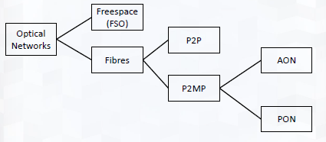
PON Architecture

 Optical Line Terminal (OLT) – Central Office node
 Optical Network Units (ONU) – one or more user node
 Optical Distribution Network (ODN) – fibers and splitters between ONU and OLT
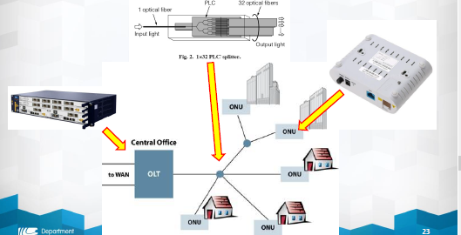
 Fibre to the x (FTTX) is a generic (genel) term (terim) for network architecture using optical fiber to provide all or part of the local loop used for last mile.
 We distinguish (ayirmak):
- FTTB (Fiber-to-the-building) – fiber reaches the boundary (sınır) of the building.
- FTTC (Fiber-to-the-curb (kaldirim kenari) / Fiber to the cabinet) – this is very similar to FTTN, but the street cabinet or pole (direk, cubuk) is closer to the user’s premises; typically within 300m.
- FTTD (Fiber-to-the-desk) – fiber connection is installed from the main computer room to an outlet near the user’s desk.
- FTTH (Fiber-to-the-home) – fiber reaches the boundary of the living space, such as a box on the outside wall of a home.
- FTTN (Fiber-to-the-node) – fiber is terminated in a street cabinet up to several kilometers away from the customer premises

GPON
 Gigabit Passive Optical Networks
 defined by G.984.1
 uses the general PON architecture
 Optical Splitter merely (sadece) divides the optical power into N separate paths to the users. The optical paths can vary (degismek) between 2 to 128.
 basic parameters:
- downlink and uplink bitrate up to 2,488 Gbit/s
- range up to 20 km
- dividing ratio up to 1:64
 new protocol GEM (GPON Encapsulation Method) is defined
EPON
 Gigabit Ethernet Passive Optical Networks
 defined by IEEE 802.3ah
 uses the general PON architecture
 basic paramaters:
- downlink and uplink bitrate up to 1,25 Gbit/s
 a standard Ethernet frames are used
10GEPON
 10Gbit/s variant
 back compatible (uyumlu) with 802.3ah
 10/1GBASE-PRX – 10 Gbit/s for downstream, 1 Gbit/s for upstream
 10GBASE-PR – 10 Gbit/s symmetically
 sharing of bandwidth is based on TDMA (Time-division multiple access) for upstream and on FDMA (Frequency-division multiple access) for downstream
WDM-PON
 aim: combine more optical channels to one fibre by Wavelength Division Multiplex
 use of a completely separate downstream wavelength for each of the subscribers.
 this separate wavelength provides more bandwidth to each subscriber

NG-PON

 NG-PON1, sometimes as XG-PON (ITU G.987)
 NG-PON2
- over 40 Gb/s
- over 40 km
- 1:64
- as final technology – TWDM-PON is used
- flexible transition (gecis) from GPON -> NG-PON2
- 1596-1603 nm for downstream
- 1524-1544 for upstream
- downstream and upstream is divided into 8 channels (wavelengths)
- up to 80 Gb/s symmetrically per one fibre!
PON evolution (evrim, gelisim)
